**REACT WEEK 6 HANDS-ON-1**

1. Create a new React Application with the name “myfirstreact”, Run the application to print “welcome to the first session of React” as heading of that page.

**SOLUTION:**

Ensure Nodejs, react and npm are installed.

Now open the react app and create a folder and install the neede to create the react project.

Code for the given sample output.

import React from 'react';

function App() {

  return (

    <div>

      <h1>Welcome to the first session of React</h1>

    </div>

  );

}

export default App;

**CMD OUTPUT**

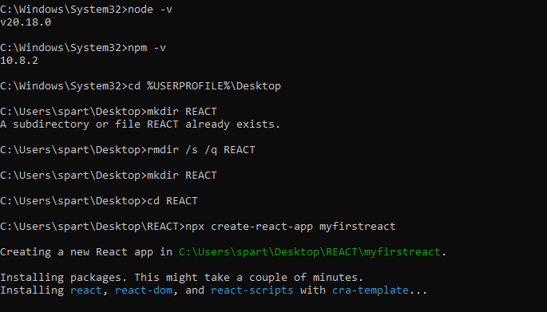

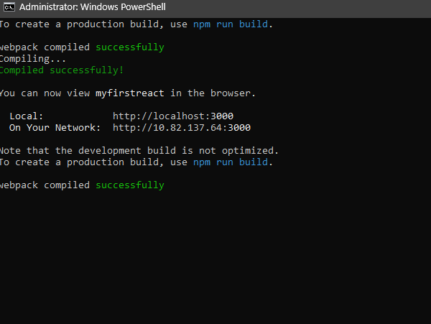

**CHROME OUTPUT**

